



**ACL Analytics Module Accounts Payable &**

**Vendor Master**

**Payroll & Employee Master**

**Exception Tests**

**User Instruction**

**Prepared by**

**Nancy Li**

**23/04/2014**

**Date**

*Prepared by Nancy Li Wednesday, November 5, 2014* **www.satorigroup.com.au**

**SYDNEY OFFICE**   
**T** 02 9667 3866 **F** 02 9667 3966   
**A** Level 1, 55 Bourke Road, Alexandria NSW 2015

TABLE OF CONTENTS

1 Overview 3

1.1 Solution Overview 3

1.2 Operation Procedures 3

1.3 Source Tables required from FINANCE System 4

1.4 Source Tables required from PayGlobal System 5

1.4 TGG ACL Analytics Module 5

2 TGG ACL Analytics Module Menu Introduction 7

2.1 Import Source Data from SAP 8

2.2 Data Mapping 11

2.3 Convert data into Fraud Module 12

2.4 Run ABN Checker 14

2.5 Execute exception tests 15

2.5.1 Vendor Master Files tests 16

2.5.2 Accounts Payable Tests 16

2.5.3 Employee Master Files Tests 17

2.5.4 Payroll Tests 17

2.5.5 Test Option 18

2.6 Export test results 18

2.7 Run All Components in a Batch 21

3 ACL Reports Extractor 23

4 Enable running Macro in ACL Reports Extractor 28

5 Grey List 31

6 Installation 35

6.1 TGG ACL Analytics Module Application Backup 35

6.2 Copying TGG ACL Analytics Module Application 36

6.3 Creating Shortcuts 36

6.4 Testing 36

# Overview

## Solution Overview

ODBC

9. Grey List

**Finance System**

1. GLF_CHART_ACCT

2. GLF_LDG_ACC_TRANS

3. GLF_LDG_ACC_TRANSD

4. GLF_LDG_TRN_ALLOC

**PayGlobal**

1. Employee
2. EmployeeHistory
3. NextOfKin
4. EmployeeStatus
5. EmplLeaveRequest
6. TransCurrentMaster
7. TransPerPaySequence
8. PayPeriod

**Analytics Module**

1. Import Source  
2. Data Mapping  
3. Convert into ACL Standard Tables  
4. Run ABN Checker  
5. Execute Test  
6. Export Results into .Del file  
7. ACL Report Extractor

**Exceptional reports**

Excel Spreadsheet

**Input**

**ACL Analytics 10**

**Output**

7. ACL Report Extractor

**ABR Website**

## 1.2 Operation Procedures

1. Import source files from Finance system into ACL via ODBC.
2. Link source filed to TGG ACL Analytics Module standard field by using ACL Fraud menu (Optional).

*This is optional, because when Nancy installed the application, have set it up. Users don’t have to run this step.*

1. Convert Data into ACL Standard Tables by using ACL menu.
2. Run ABN Checker to obtain latest ABN status information from ABR website
3. Run exception tests
4. Export tests results into delimited files
5. Use ACL Report Extractor to load all files into one Excel spread sheet with pretty format.
6. Exit/Done
7. Grey list maintenance

For more details, please refer to the next sections.

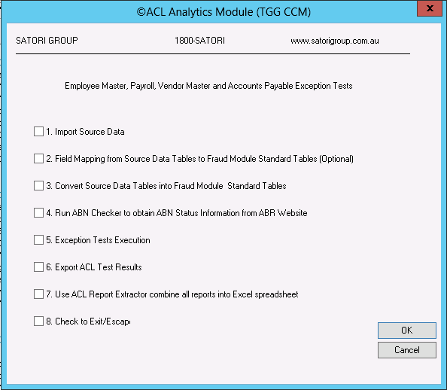

## Source Tables required from FINANCE System

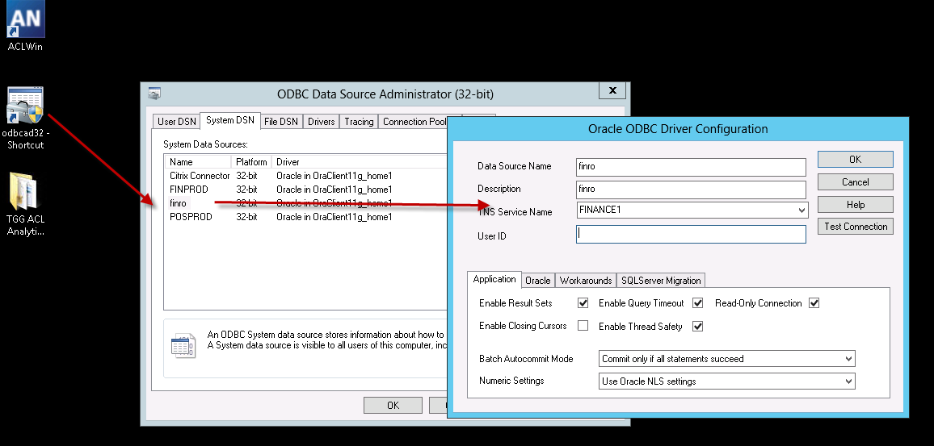

ACL only accepts 32 bit ODBC driver. ( C:\Windows\SysWOW64\odbcad32.exe)

TGG create 32 bit ODBC connections for Finance1 System, e.g. **FINTPROD**

Provide public ACL user “**fino**” with read permission to the following tables:

1. GLF_CHART_ACCT

2. GLF_LDG_ACC_TRANS

3. GLF_LDG_ACC_TRANSD

4. GLF_LDG_TRN_ALLOC

## Source Tables required from PayGlobal System

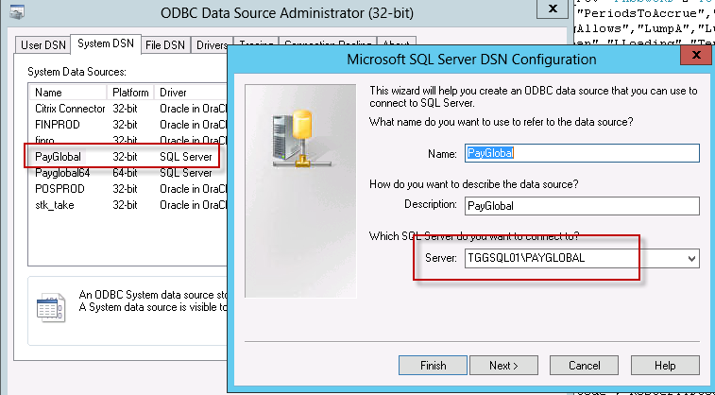

TGG create 32bit ODBC connections for PayGlobal System, e.g. **PayGlobal**

Provide public ACL user “**tggacl**” with read permission to the following tables:

1. Employee
2. EmployeeHistory
3. NextOfKin
4. EmployeeStatus
5. EmplLeaveRequest
6. TransCurrentMaster
7. TransPerPaySequence
8. PayPeriod

## 1.4 TGG ACL Analytics Module

TGG ACL Analytics Module has been installed on server (tggaclprd.tgglocal.com.au )

**Start -> Programs -> TGG ACL Analytics Module**

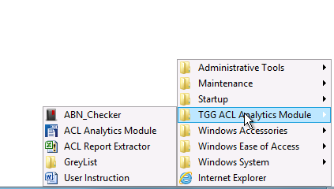

* **TGG ACL Analytics Module** – ACL application to import/convert/execute tests/generate exceptions into ACL files.
* **ACL Report Extractor** – Excel application to extract all ACL exceptional results into excel spreadsheet.
* **GreyList** – to maintain the greylist into excel files, so you can grey list the employee from the particular test.
* **User Instruction** – lead you to this user menu.
* **ABN Checker** – obtain the latest ABN information from ABR website

**Source Files for the application**

On the user computer, the relevant applications are prepared on the folder “**E:\ACL_PROJECTS\TGG_CCM**”, open this folder, you can find all the source files for the **TGG ACL Analytics Module** application for UTAS, as well as their test results and grey list folder.

**TGG ACL Analytics Module Application** is installed in   
E:\ACL_PROJECTS\TGG_CCM

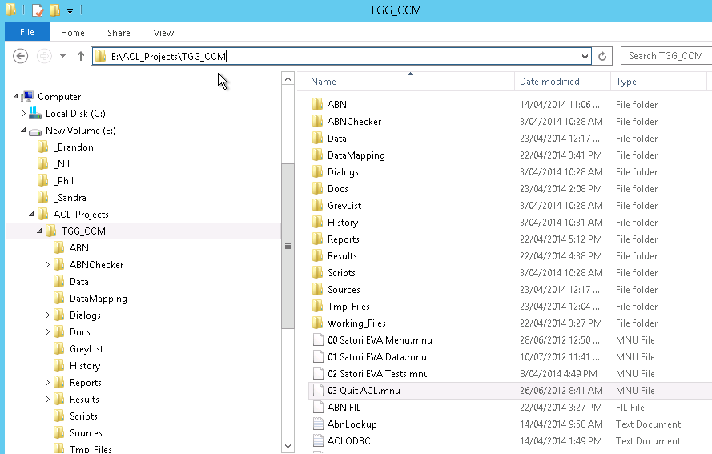

# TGG ACL Analytics Module Menu Introduction

Click **Start -> Programs -> TGG ACL Analytics Module -> TGG ACL Analytics Module**

Or Click the short cut on the desktop – **TGG ACL Analytics Module**

The ACL application is now opened. You can choose Main Menu:

click **Applications - > 01 Satori EVA Menu -> Main Menu**

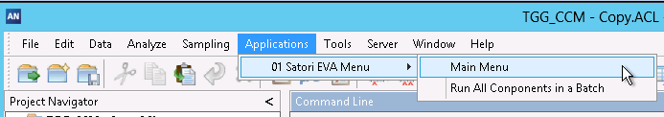

**The procedures normally split into 8 steps:**

* 1. Import source data into ACL
* 2. Link Data Fields or set up the Mapping (Optional)
* 3. Convert Source Data into ACL Module Standard Tables
* 4. Run ABN Checker to obtain ABN Status Information from ABR Website
* 5. Exception Tests Execution
* 6. Export ACL Test Results into delimited files
* 7. Use ACL Report Extractor combine all reports into Excel spreadsheet
* 8. Exit the application

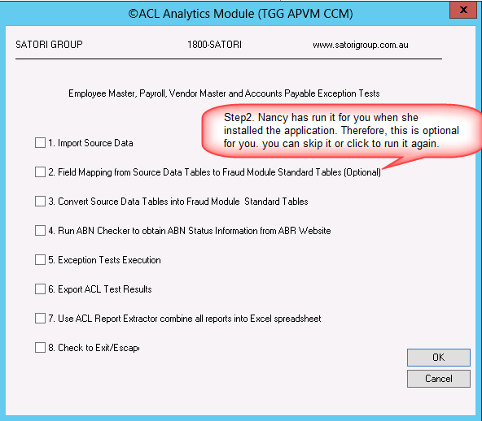

## 2.1 Import Source Data from SAP

Before importing the source data, please make sure the server where the fraud module is implemented has the ODBC connection setup property by IT, for more information please refer to **section 1.3**.

Check the first item “**1. Import Source Data**”, then click OK.

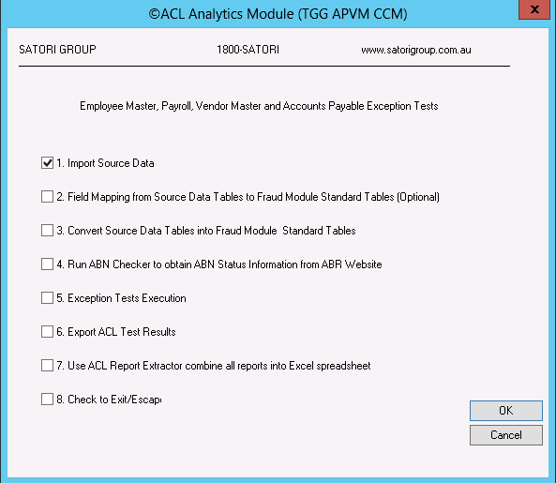

To avoid the data extraction taking too long, so please make sure the data range period is less than 1 year.

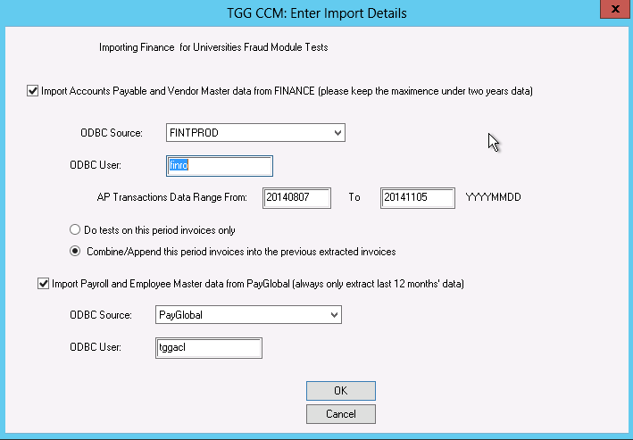

You can either select checkbox “Import AP & VM data from FINANCE system” or select checkbox “import Payroll and EM data from PayGlobal” or select both.

There is an option for you to choose to **Do tests on this period invoices only** or **Combine/Append this period invoices into the previous extracted invoices** for the accounts payable tests.

* **Do tests on this period invoices only –** for example, if you only want to do the tests based on the period that you just provide on the data range input boxes, and clear out the old extracted data, then you should choose this option.
* **Combine/Append this period invoices into the previous extracted invoices** – if you have import data into this ACL Fraud Module, for example, 6 months from 01/01/2013 to 30/06/2013. Now you want to extract another 6 months data from 01/07/2013 to 31/12/2013, and you want to do the Accounts Payable tests (e.g. duplicate invoices) on a whole year period, then you should choose this option. This fraud module will combine the new period data into the that data that have been on the Module.

Click OK, then enter a correct password for FINANCE1 (user finro)

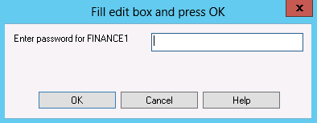

If you choose to import data from PayGlobal, then please enter password for PayGlobal

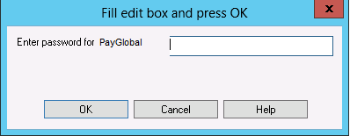

Click OK, the ACL starts import the data, it might take hours depends on how big are the source files.

When it is finished, it will show you a message window to tell you that this step has been imported successfully.

## 2.2 Data Mapping

This is to link SAP files’ fields to TGG ACL Analytics Module standard fields.

When it’s the first time you just implement the TGG ACL Analytics Module, you need to run this step. After that, it is an optional step for the user to run.

*As for this step, Nancy Li has run it for you when she installed the application. So it is optional for you to run it or not.*

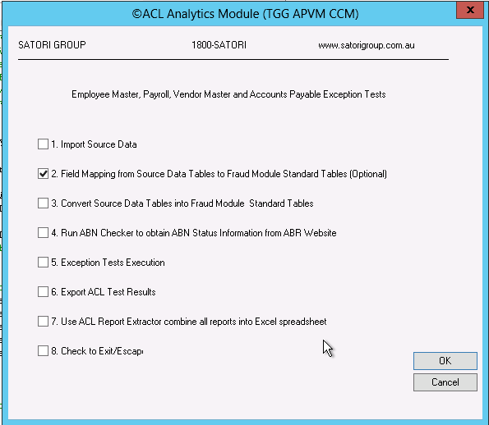

When it finish, it will show you a message window to tell you that this step has been imported successfully.

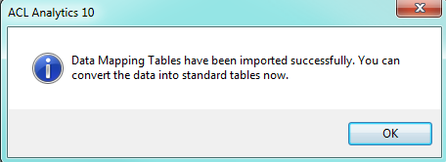

Please click OK and then you can go to next step.

## 2.3 Convert data into Fraud Module

Click the check box 3. Convert Source Data Tables into ACL

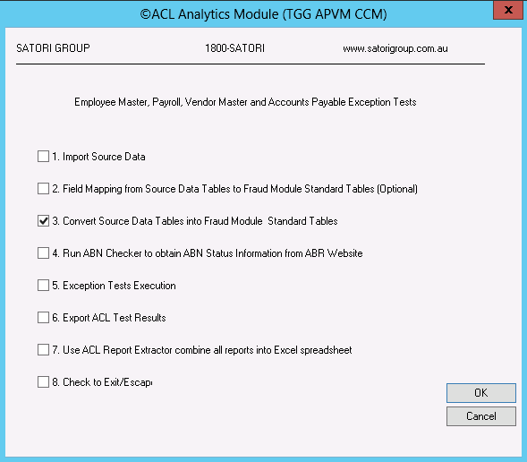

Choose the segments you want to convert.

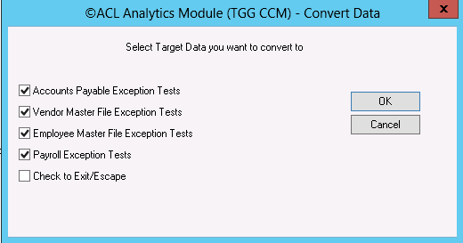

When it finish, it will show you a message window to tell you that this step has been imported successfully.

Please click OK and then you can go to next step.

## 2.4 Run ABN Checker

Once you have converted the source data into Fraud Module, you need to run the ABN checker to obtain the latest ABN information from ABR website before you start to run the tests.

Check the check box **6. Run ABN Checker**

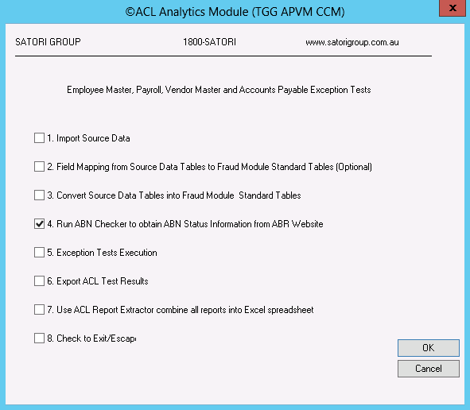

It would take you for a while, for example 2 to 4 hours depends on how many the vendor master ABN records are. You just have to wait until it finished.

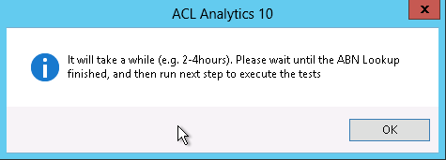

Click OK, the ACL Analytics model will run the ABN Checker to obtain the latest ABN status from the ABR website.

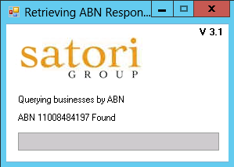

This window will be closed when all ABN(s) information have been updated from the ABR Website.

## 2.5 Execute exception tests

Check the check box **5. Execption Tests Execution**

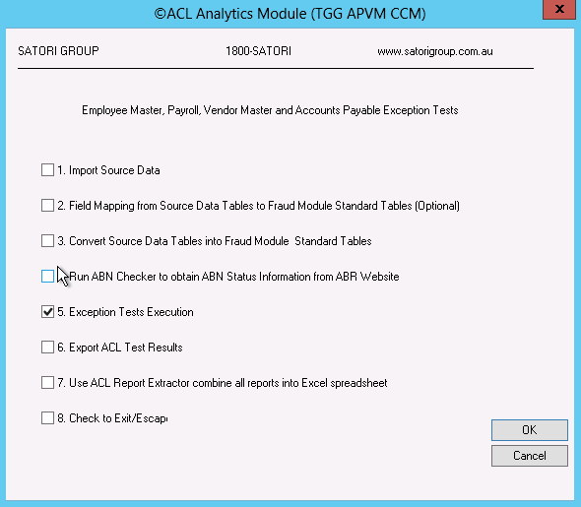

Click Ok

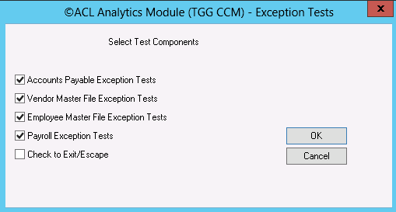  
By default, all available vendor master files tests are selected, you also can adjust the tests you want to run or change the input parameters, then click OK.

### 2.5.1 Vendor Master Files tests

By default, all available Vendor Master file tests are selected.

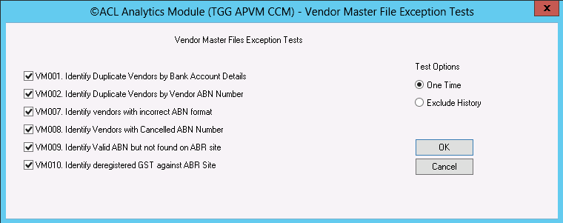

### 2.5.2 Accounts Payable Tests

By default, all available Accounts Payable tests are selected.

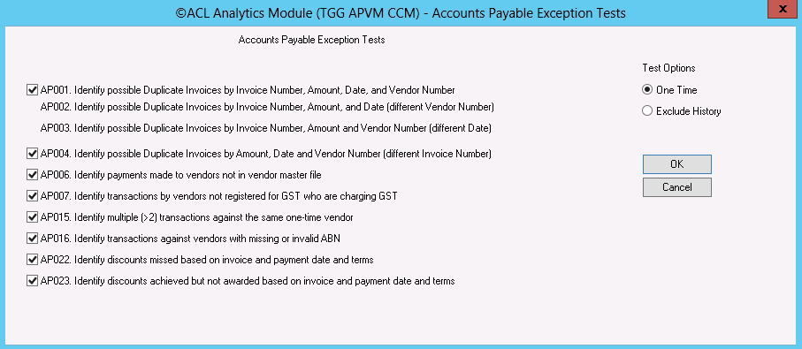

### 2.5.3 Employee Master Files Tests

By default, all available Employee Master File exception Tests are selected.

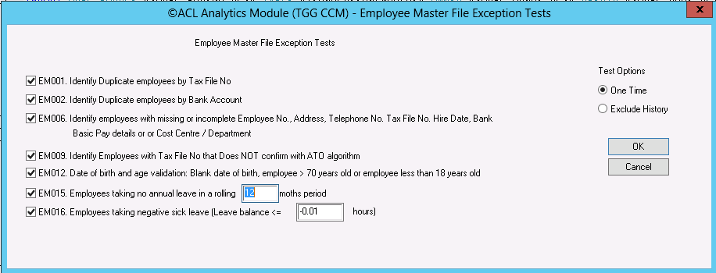

### 2.5.4 Payroll Tests

By default, all available Payroll exception tests are selected.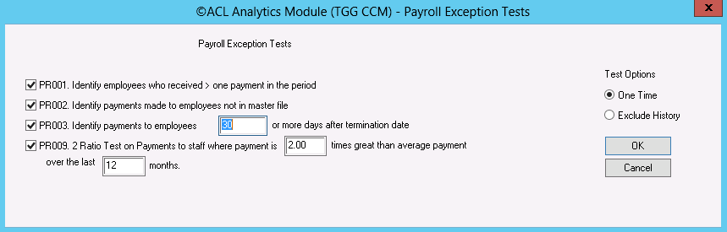

You can change the default values for the **input parameters** in the input boxes. And then click OK.

Once all tests have been executed, the system will give you a message to let you know the tests have been run successfully.

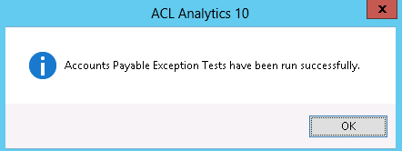

Click OK you can go to the next step.

### 2.5.5 Test Option

In each component menu, there is a test option to allow you to run tests on “One Time” or “Exclude History”:

* One Time – list all exceptions into the report outputs.
* Exclude History – running reports and storing the exception into history tables, therefore, for the next report runs that is based on the new data set, when user still choose “Exclude History”, ACL Analytics Module only picking exception that occur only since the last script was run.

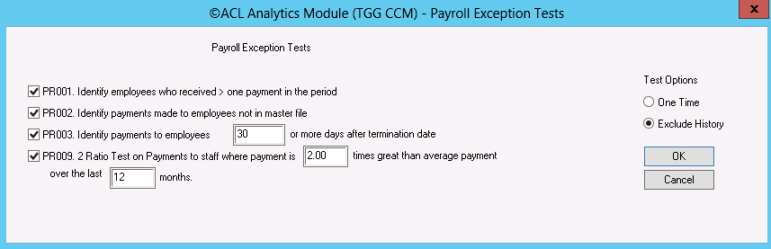

## 2.6 Export test results

Go to TGG ACL Analytics Module -> Main Menu, Check the check box **6. Export ACL Test Results**

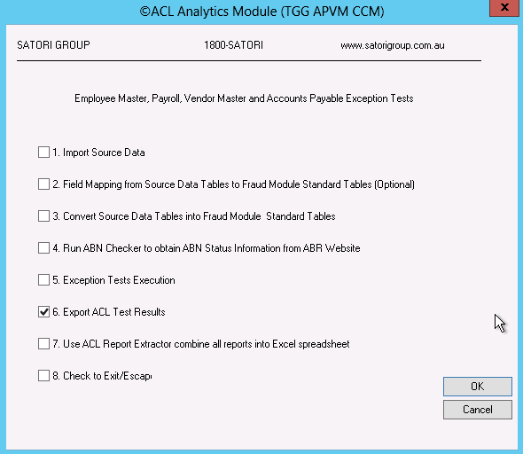

Click OK. We suggest you just use all default settings, click OK.

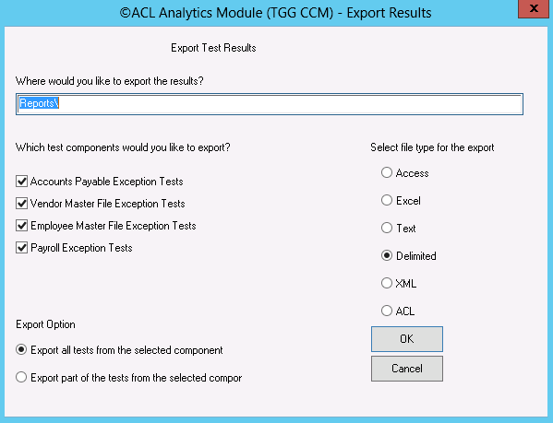

On this screen, strongly recommend you chose “**Delimited**” file type for the export. Because this is the default file type that the ACL Report Extractor can convert and combine all ACL reports results into the Excel spreadsheet.

Click OK, you have export the all reports into the folder “**Reports**” under the TGG ACL Analytics Module installation folder. (E:\ACL_PROJECTS\TGG_CCM\Reports)

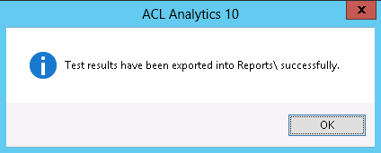

## 2.7 Run All Components in a Batch

Click **Start -> Programs -> TGG ACL Analytics Module -> TGG ACL Analytics Module**

Or Click the short cut on the desktop – **TGG ACL Analytics Module**

The ACL application is now opened. You can choose Run All Components in a batch:

Click **ACL Menu -> Applications -> 01 Satori EVA Menu -> Run All Components in a batch**

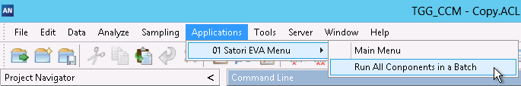

This procedures will combine all steps described above by using default options and input parameters for all components, includes (AP,VM,EM &PR):

* 1. Import all source data into ACL
* 2. Link Data Fields or set up the Mapping
* 3. Convert Source Data into ACL Module Standard Tables
* 4. Run ABN Checker to obtain ABN Status Information from ABR Website
* 5. Exception Tests Execution
* 6. Export ACL Test Results into delimited files
* 7. Load ACL Report Extractor (a mall Excel program that allow you convert the results into one excel spreadsheet).

However, user still needs to manually operate the ACL Report Extractor, please refer to Section 3. ACL Reports Extractor



Click OK, you need to provide the passwords for the user “finro” for Finance, user “tggacl” for PayGlobal.

Click OK, then enter a correct password for FINANCE1 (user finro)



Enter password for PayGlobal



It will take several hours for the ACL to run all steps. It is recommended to submit those jobs in a batch off-work hours.

Once all jobs are finished, the excel program of “ACL Report Extractor” will be open in the window task bar.



Click the **Excel** **Icon**, you will see the ACL Report Extractor in the following screen.

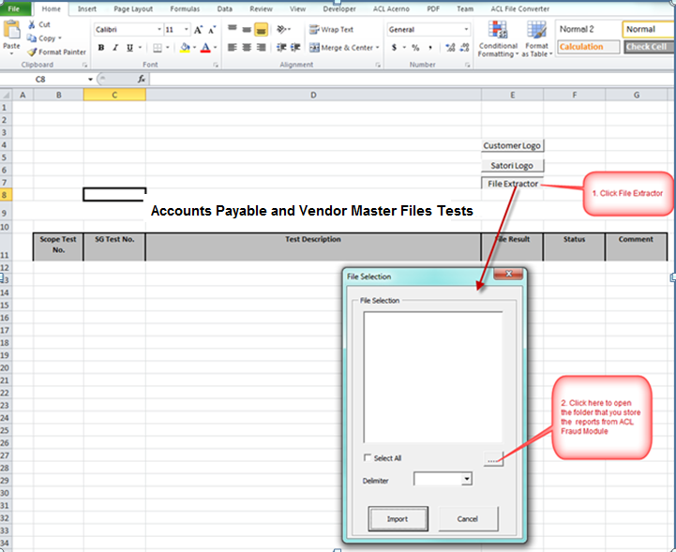

# ACL Reports Extractor

If you want to load all the ACL results into Excel spreadsheet, then you can use this tool “ACL Reports Extractor” to combine and format the results into one Excel files.

**Also, before you use it, you need to make sure you have the Microsoft Office installed on the computer or server you are using this tool.**

Go to **TGG ACL Analytics Module -> Main Menu**, Check the check box **7. Use ACL Report Extractor combine all reports into Excel spreadsheet**

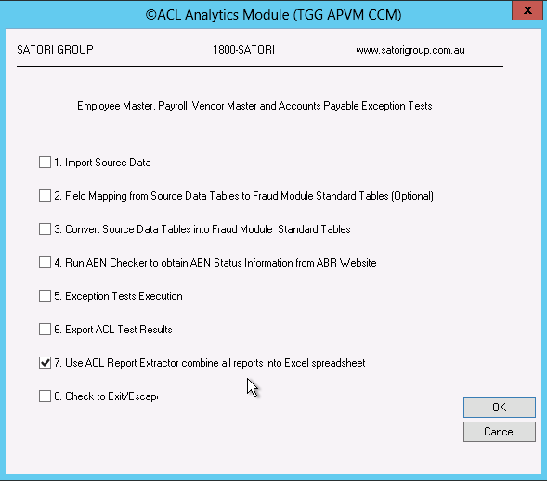

**Or**

**Start -> Programs -> TGG ACL Analytics Module -> ACL Report Extractor**

It is an excel application, on the main screen, you will see three buttons:

* **Customer Logo** – to put your company logo into this finial report; (optional)
* **Satori Logo** – to put the Satori Logo into this final report; (optional)
* **File Extractor** – to choose the individual reports to extract.

Click button “File Extractor”.



Click button “….” on the dialog.

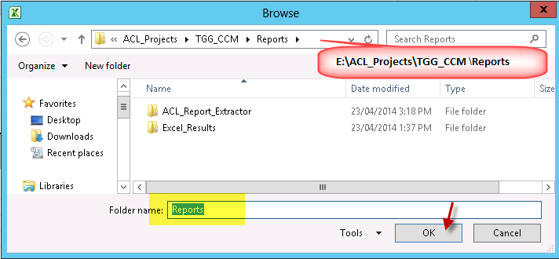

Click OK. The dialog now is showing you all reports ended by .DEL.

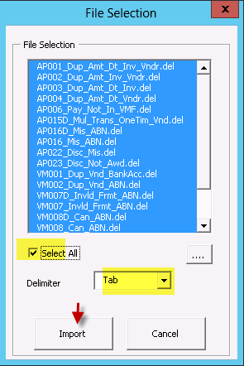

You can choose the individual report or you can select all to choose all the reports. In the Delimiter section, please choose “Tab”, then click Import.

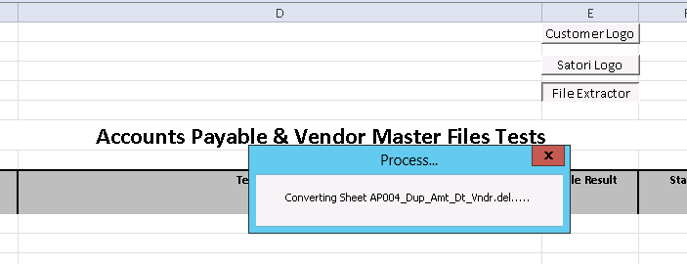

Now this ACL Report Convertor will take some time to convert and format the files that you choose. When it finished, it will lead you to the next screen, ask you to save the file.

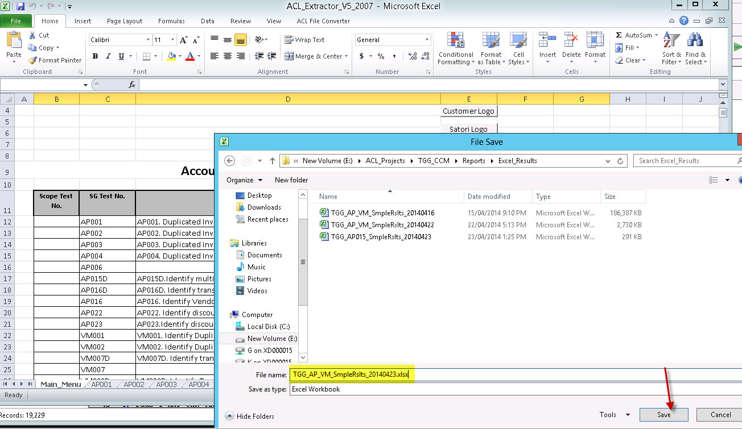

Choose the Folder that you store the reports generated from TGG ACL Analytics Module, by default, it would store in the **E:\ACL_Projects\TGG_CCM \Reports\Excel_Results**

Click OK. And then Click Yes.

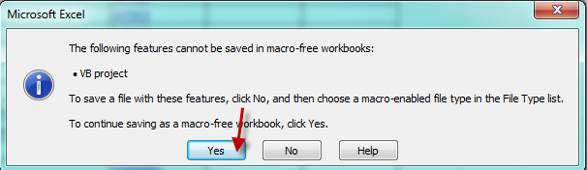

Now all the reports are formatted. You can review the results or do your own investigation.

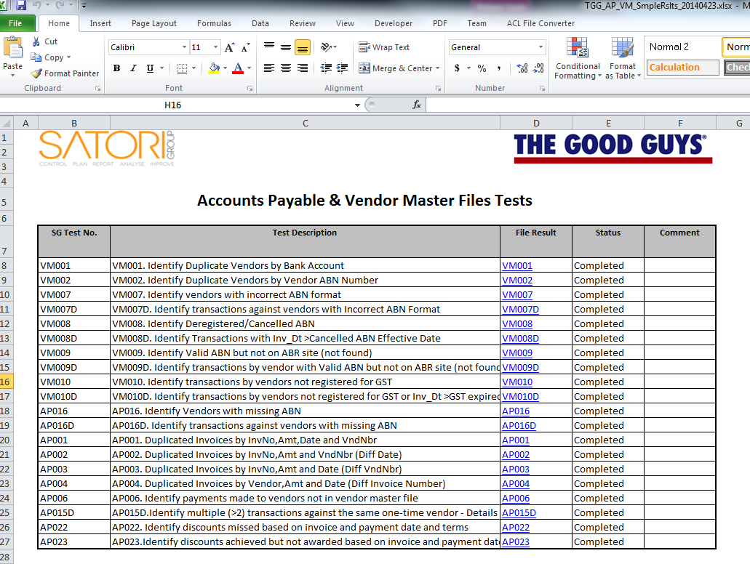

# Enable running Macro in ACL Reports Extractor

When it is your first time to use the ACL Reports Extractor, you might get some trouble or could not click the button on the main excel spread sheet.

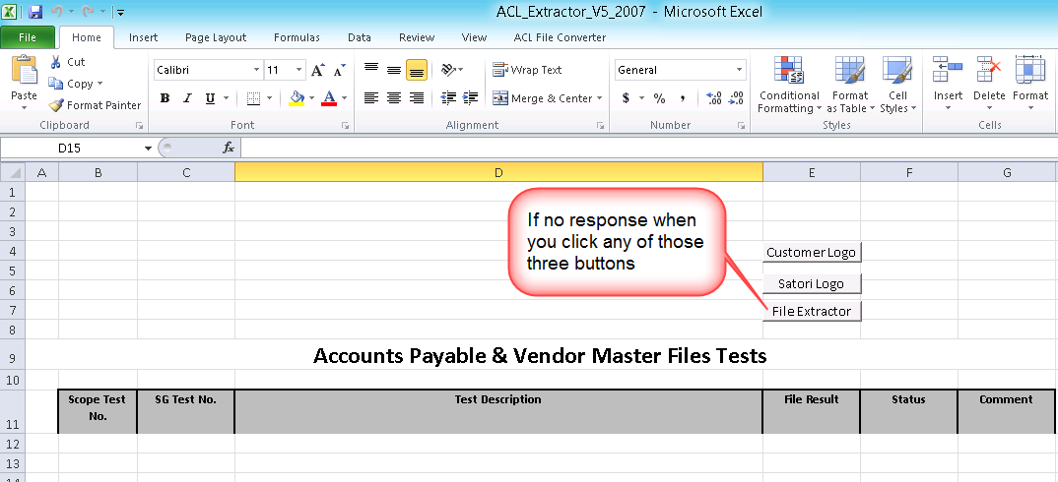

To enable the Macro in Excel, please follow the following procedures.

1. Open Excel, right click the Microsoft button at the left hand side of the top. Then click **Excel Options**

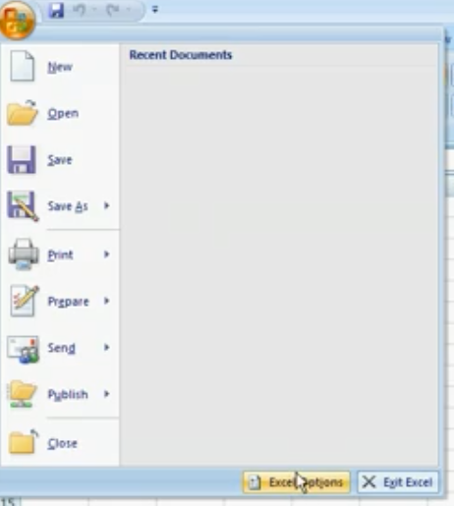

1. Click Trust Center, then click Trust Center Settings….

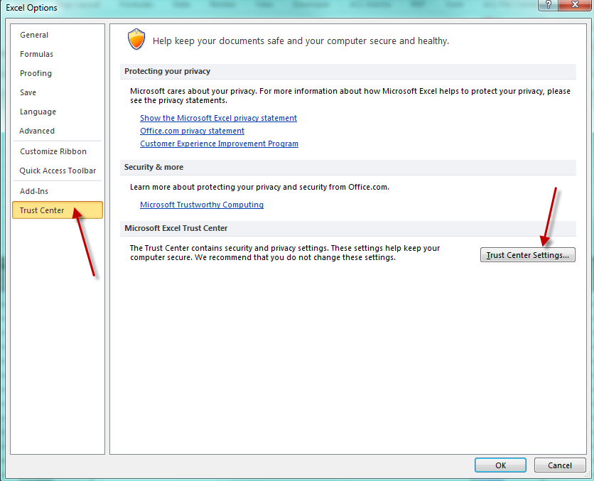

1. Move your mouse to **Macro Settings** Tab,

* Choose the option on the right hand side of the screen: Enable all macros (not recommended, potentially dangerous code can run)
* Check the check box: Trust access to the VBA project object model
* Then click OK

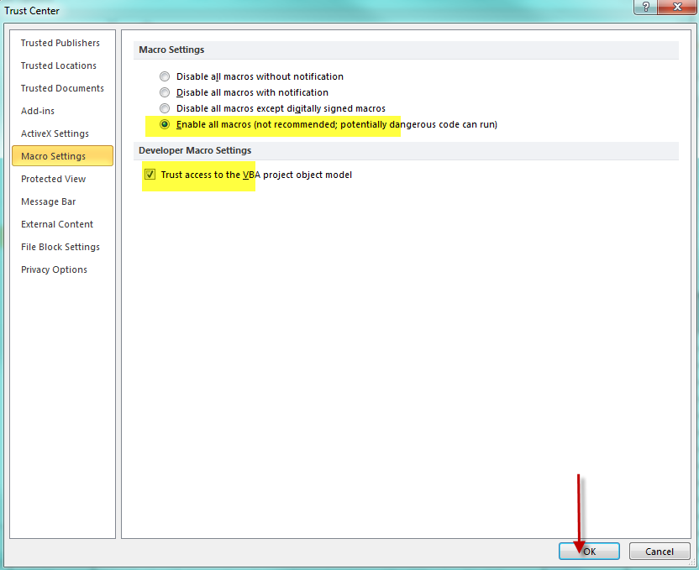

1. Close the excel, re-open the **ACL Report Extractor**

Go to **TGG ACL Analytics Module -> Main Menu**, Check the check box **7. Use ACL Report Extractor combine all reports into Excel spreadsheet**

**Or**

**Start -> Programs -> TGG ACL Analytics Module -> ACL Report Extractor**

You should be able to click the button and extract the reports into Excel.

# Grey List

**Start -> Programs -> TGG ACL Analytics Module -> GreyList**, click the shortcut of the grey list folder (E:\ACL_PROJECTS\TGG_CCM\GreyList).

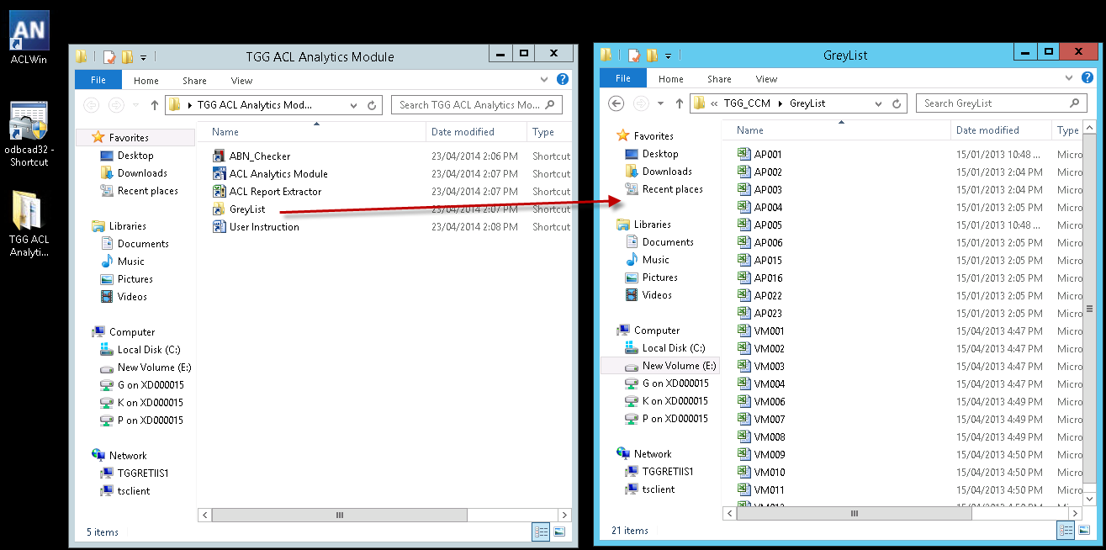

Then click the individual Grey List excel file. E.g. VM001 you want to apply the grey list logics.

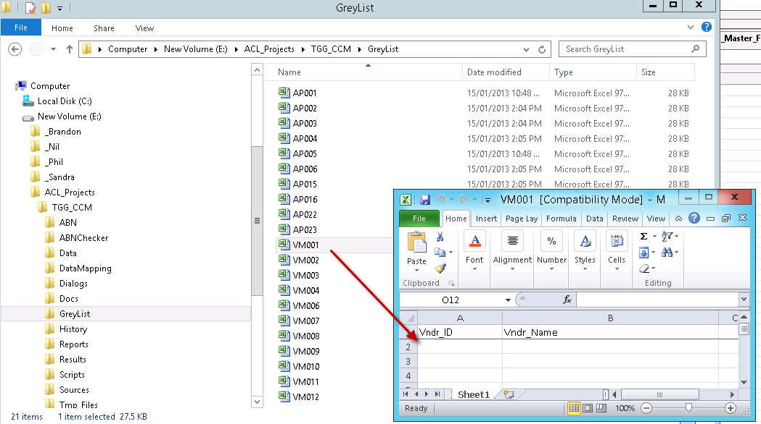

Put the Vendor number (Please make sure it’s exactly the same format of the Vendor Number, e.g. 00001) and Vendor into the grey list excel spread sheet.

Vendor Number is mandatory; Vendor name is optional information.

Close the grey list excel file.

Go to the TGG ACL Analytics Module, and rerun the particular test(s) you want to regenerate the results.



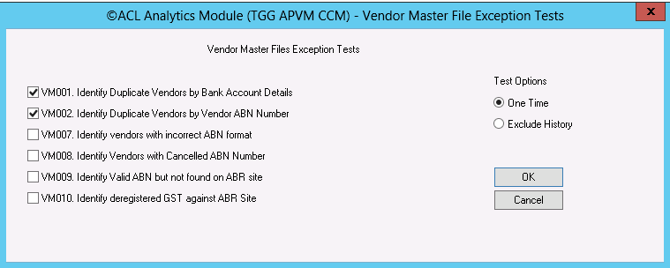

And then Export the reports



Here, you can choose to only export the tests

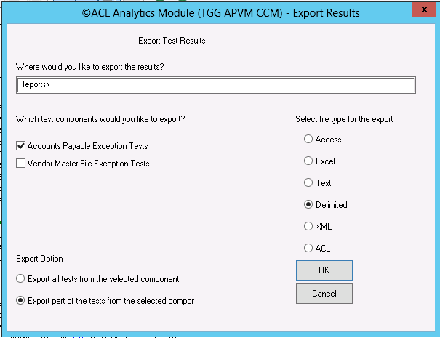

And then use the **ACL Report Extractor** to extract the reports into Excel spread sheet in a nice format.

When you review the results after you update the grey list. You can see the Vendor number you grey listed (e.g. 00010842) not there anymore.

# Installation

## TGG ACL Analytics Module Application Backup

The clean source application project files are stored on computer:

* E:\ACL_PROJECTS\TGG_CCM\Version_BK

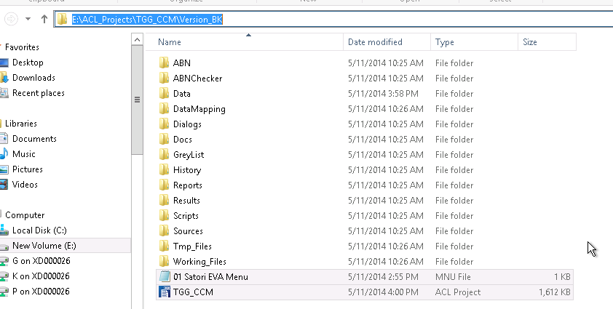

## 6.2 Copying TGG ACL Analytics Module Application

Copy the TGG ACL Analytics Module Application folder “E:\ACL_PROJECTS\TGG_CCM**”**  into a folder in other user computer: e.g. **C:\ACL_Projects**

**If you get any issue, please contact satori support.**

**SATORI Support: +61 2 9667 3866**

6.3 Creating Shortcuts  
Open folder:

**E:\ACL_PROJECTS\TGG_CCM\Docs\Shortcuts**

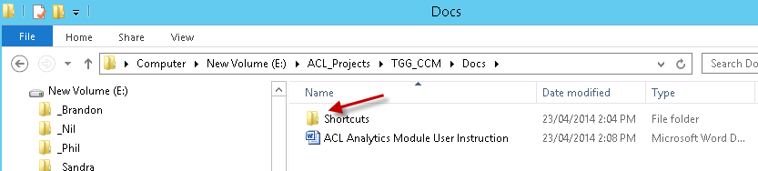

From where you can see a sub folder called “TGG ACL Analytics Module”, please copy this folder, and then copy to the destination folder:

C:\Users\ACLAdmin\AppData\Roaming\Microsoft\Windows\Start Menu\Programs\

## 6.4 Testing

Start -> Programs -> TGG ACL Analytics Module

You should be able to see 4 shortcuts for relevant TGG ACL Analytics Module components.



Now you can use the TGG ACL Analytics Module.